**EXPERIMENT NO.1**

**NOTE-**  All the diagrams should be drawn on left hand side (blank page) and theory should be written on right hand side (ruled page). Diagrams should be drawn with pencil compulsory.

**AIM-** Introduction and study of components.

**APPARATUS**- Breadboard, IC, Dual DC power supply, Resistor, LED.

**THEORY-**

1. Breadboard-

1. An electronics breadboard is actually referring to a **solderless breadboard**. These are great units for making temporary circuits and prototyping, and they require absolutely no soldering.

**2. Prototyping** is the process of testing out an idea by creating a preliminary model and it is one of the most common uses for breadboards. If you aren’t sure how a circuit will react under a given set of parameters, it’s best to build a prototype and test it out.

3. Breadboard is divided into two section horizontal and vertical. Hole A1 is electrically connected to holes B1, C1, D1, and E1. It is *not* connected to hole A2, because that hole is in a different row, with a separate set of metal clips. It is also *not* connected to holes F1, G1, H1, I1, or J1, because they are on the other "half" of the breadboard. Strips are marked by red and blue (or red and black) lines, with plus (+) and minus (-) signs, respectively. They are called the buses, also referred to as rails, and are typically used to supply electrical power to your circuit when you connect them to a battery pack or other external power supply.

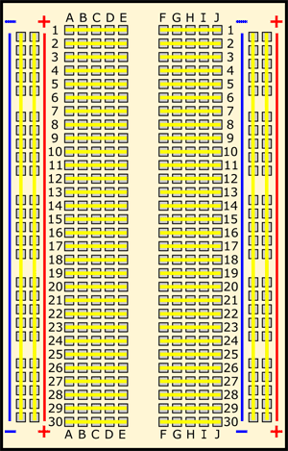

1. LED- (Light emitting diode)-

1. A light-emitting diode (LED) is a two-[lead](https://en.wikipedia.org/wiki/Lead_%28electronics%29) [semiconductor](https://en.wikipedia.org/wiki/Semiconductor) [light source](https://en.wikipedia.org/wiki/Light_source). LEDs are a particular type of [diode](https://learn.sparkfun.com/tutorials/diodes/introduction) that convert electrical energy into light.

2. The positive side of the LED is called the **“anode”** and is marked by having a longer “lead,” or leg. The other, negative side of the LED is called the **“cathode.”**

3. Current flows from the anode to the cathode and never the opposite direction. A reversed LED can keep an entire circuit from operating properly by blocking current flow.

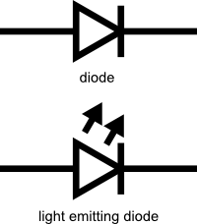 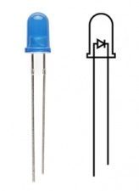

1. Resistors-

1. In electronic circuits, resistors are used to reduce current flow, adjust signal levels, to divide voltages etc. The [ohm](https://en.wikipedia.org/wiki/Ohm_%28unit%29) (symbol: [Ω](https://en.wikipedia.org/wiki/%CE%A9)) is the [SI](https://en.wikipedia.org/wiki/International_System_of_Units) unit of [electrical resistance](https://en.wikipedia.org/wiki/Electrical_resistance).

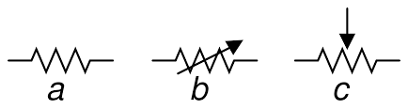

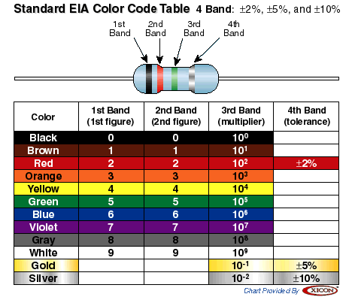

1. Integrated circuit-

An integrated circuit (IC), sometimes called a chip or [microchip](http://searchcio-midmarket.techtarget.com/definition/microchip), is a [semiconductor](http://searchcio-midmarket.techtarget.com/definition/semiconductor) wafer on which thousands or millions of tiny resistors, capacitors, and [transistor](http://searchcio-midmarket.techtarget.com/definition/transistor)s are fabricated. An IC can function as an [amplifier](http://searchcio-midmarket.techtarget.com/definition/amplifier), [oscillator](http://searchcio-midmarket.techtarget.com/definition/oscillator), timer, counter, computer [memory](http://searchmobilecomputing.techtarget.com/definition/memory), or microprocessor. A particular IC is categorized as either linear ([analog](http://searchcio-midmarket.techtarget.com/definition/analog)) or [digital](http://searchcio-midmarket.techtarget.com/definition/digital), depending on its intended application. Digital ICs operate at only a few defined levels or states, rather than over a continuous range of signal amplitudes. These devices are used in computers, computer networks, modems, and frequency counters. The fundamental building blocks of digital ICs are [logic gate](http://whatis.techtarget.com/definition/logic-gate-AND-OR-XOR-NOT-NAND-NOR-and-XNOR)s, which work with binary data, that is, signals that have only two different states, called low (logic 0) and high (logic 1).

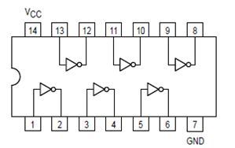

HD74LS04P

1. DC power supply-

**A DC power supply is a device that supplies electric energy of fixed polarity, either positive or negative.** "DC" in this context means "direct current." Direct current is an alternative to alternating current, frequently shortened to "AC."

*Draw the diagram of dc power supply*